AI Phase-1 Documentation:
Dataset Description:
Real-World Dataset — Pakistan Province-Level Surveillance
The primary dataset is a province-wise monthly dengue surveillance record for Pakistan covering January 2016 to December 2020, obtained from Kaggle, publicly available on the https://www.kaggle.com/code/aamir28/pakistan-dengue-outbreak-analysis-2016-2020/input. The province-based data set has been adopted from Kaggle due to the irresponsiveness of the national institute of health where the initial dataset was requested. It covers all seven administrative regions — Punjab, Sindh, Khyber Pakhtunkhwa, Balochistan, Islamabad Capital Territory, Azad Jammu & Kashmir, and Gilgit-Baltistan. This dataset provides the real-world Pakistani dengue burden data used for spatial clustering and the province risk map component of the dashboard.
NASA POWER Climate API
The supplementary dataset is climate data programmatically fetched from the NASA POWER (Prediction of Worldwide Energy Resources) API, maintained by NASA's Langley Research Center and freely accessible at power.larc.nasa.gov. NASA POWER provides satellite-derived daily meteorological data at any geographic coordinate worldwide. For this project, daily climate readings were fetched for the geographic centroid coordinates of each of the 36 Punjab districts covering the same 2016–2020 period as the surveillance data. Daily readings were then aggregated to epidemiological weekly resolution before merging. This dataset provides the environmental and climate features that explain the variation in dengue case counts — features that are absent from the province-level surveillance data entirely.
Final Engineered Dataset — Punjab District-Level Weekly
Since the project's clustering and mapping component required district-level weekly granularity for Punjab, the province-level monthly dataset was transformed into a district-level weekly dataset through a documented two-stage disaggregation process including the careful use of various factors like the offseason and onseason outbreaks weights, augmented with climate data from the NASA POWER API. This final engineered dataset, named punjab_district_weekly_merged.csv, is the output of the data collection and preprocessing pipeline and serves as the input to KMeans clustering.

Dataset Features:
Dataset 1 — Pakistan Province Surveillance Features
Feature | Type |  | Description
Month | Categorical (string) | Calendar month name — "January" through "December"
Year | Numerical (integer) | Calendar year (2016–2020)
Region | Categorical (string) | Province or territory name — 7 unique values
Dengue_Cases | Numerical (integer) | Total confirmed dengue cases for that province and month
Dengue_Deaths | Numerical (integer) | Total dengue-related fatalities for that province and month
Dataset 2 — NASA POWER API Features
The raw NASA POWER API returns daily readings for each requested parameter at the specified coordinate. For this project four parameters were fetched at daily resolution and then aggregated to epidemiological weeks before merging.
Feature | Raw NASA Parameter | Aggregation | Type | Description
year | Derived from date index | — | Numerical (integer) | ISO calendar year extracted from the daily date
epi_week | Derived from date index | — | Numerical (integer) | ISO epidemiological week number extracted from the daily date.
T2M_mean | T2M | Weekly mean | Numerical (continuous) | Mean air temperature at 2 metres above ground (°C) — drives mosquito survival rate and breeding speed
RH2M_mean | RH2M | Weekly mean | Numerical (continuous) | Mean relative humidity at 2 metres (%) — high humidity extends mosquito lifespan and increases biting rate
PRECTOTCORR_sum | PRECTOTCORR | Weekly sum | Numerical (continuous) | Total bias-corrected precipitation for the week (mm) — summed rather than averaged because total rainfall accumulation determines standing water formation, not the daily average
WS10M_mean | WS10M | Weekly mean | Numerical (continuous) | Mean wind speed at 10 metres (m/s) — higher wind speeds reduce mosquito flight activity and dispersal
Final Engineered Dataset — punjab_district_weekly_merged.csv
This is the complete feature-rich dataset produced after merging Datasets 2 and 3 through disaggregation and feature engineering. It contains 8,568 rows across 36 Punjab districts and 21 features.
Feature | Source | Type | Description
year | Dataset 2 | Numerical (integer) | Calendar year (2016–2020)
month | Dataset 2 | Categorical (string) | Calendar month name
month_num | Derived | Numerical (integer) | Month as integer (1–12)
epi_week | Derived | Numerical (integer) | ISO epidemiological week number (1–52)
district | Disaggregation | Categorical (string) | Punjab district name — 36 unique values
cases | Dataset 2 + Disaggregation | Numerical (integer) | Target variable — estimated weekly dengue cases per district, derived via weighted spatial and temporal disaggregation from real Punjab provincial totals
deaths | Dataset 2 + Disaggregation | Numerical (integer) | Estimated weekly dengue deaths per district — disaggregated using identical weights to cases
T2M_mean | Dataset 3 (NASA) | Numerical (continuous) | Mean weekly temperature at 2 metres (°C) at district coordinates
RH2M_mean | Dataset 3 (NASA) | Numerical (continuous) | Mean weekly relative humidity at 2 metres (%) at district coordinates
PRECTOTCORR_sum | Dataset 3 (NASA) | Numerical (continuous) | Total weekly corrected precipitation (mm) at district coordinates
WS10M_mean | Dataset 3 (NASA) | Numerical (continuous) | Mean weekly wind speed at 10 metres (m/s) at district coordinates
month_sin | Engineered | Numerical (continuous) | Sine transformation of month number — encodes circular nature of months so December and January are treated as adjacent (range −1 to 1)
month_cos | Engineered | Numerical (continuous) | Cosine transformation of month number — paired with month_sin for complete cyclical encoding (range −1 to 1)
week_sin | Engineered | Numerical (continuous) | Sine transformation of epidemiological week — encodes week circularity (range −1 to 1)
week_cos | Engineered | Numerical (continuous) | Cosine transformation of epidemiological week — paired with week_sin (range −1 to 1)
t1_cases | Engineered | Numerical (continuous) | Lag feature — case count from the previous week (t−1). Captures outbreak temporal progression
t2_cases | Engineered | Numerical (continuous) | Lag feature — case count from two weeks prior (t−2). Reflects the 1–2 week incubation and reporting delay inherent in dengue transmission
T2M_lag1 | Engineered | Numerical (continuous) | Temperature from the previous week — captures delayed effect of heat on mosquito breeding
PRECTOTCORR_lag1 | Engineered | Numerical (continuous) | Rainfall from the previous week — mosquito breeding responds to prior week rainfall more than current
PRECTOTCORR_lag2 | Engineered | Numerical (continuous) | Rainfall from two weeks prior — captures cumulative delayed effect on standing water formation
water_proxy | Engineered | Numerical (continuous) | Two-week rolling sum of precipitation — proxy for standing water accumulation and mosquito breeding conditions
Data Summary:
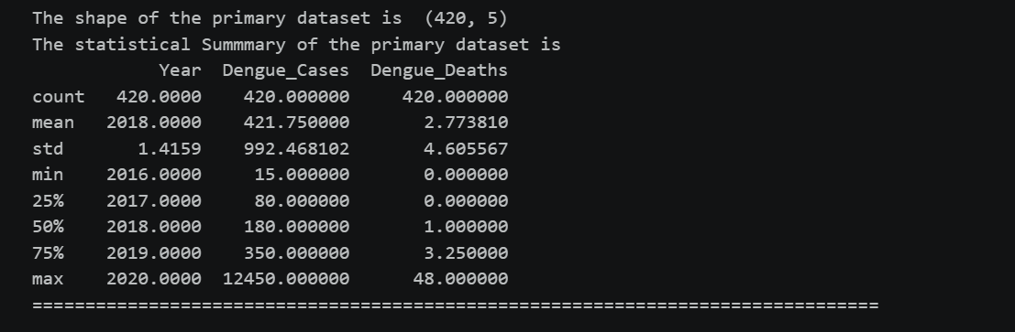
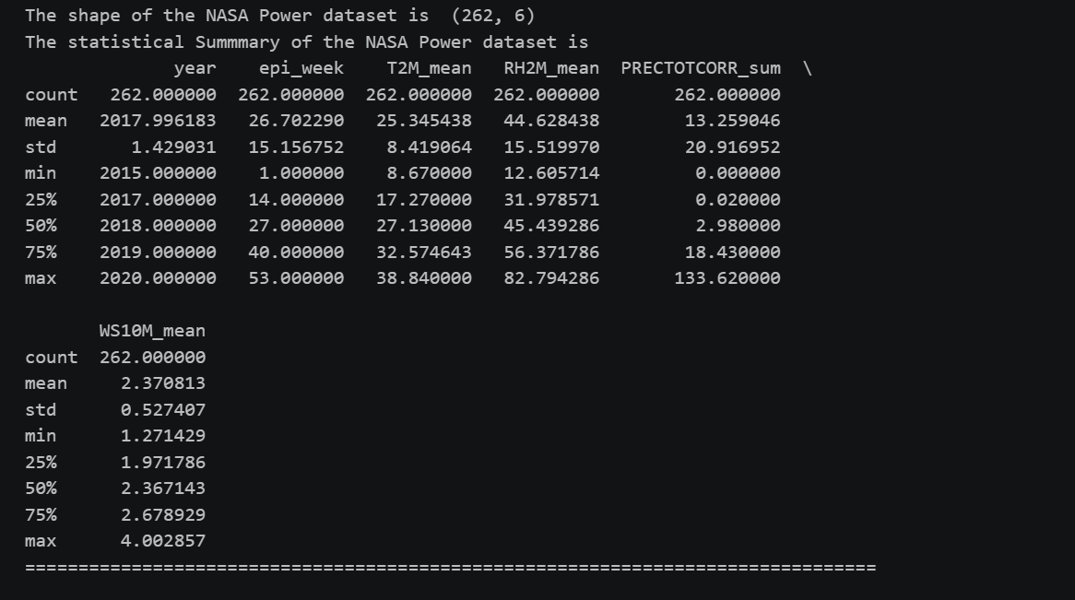
Final Engineered dataset summary is too large to place here
Data Visualization:
All the graphs are available in the notebook

Methodology
Proposed Analytical Approach
The dengue outbreak prediction problem is decomposed into three distinct machine learning tasks, each addressed by a dedicated model or model family. The overall methodology follows a supervised learning paradigm for case count prediction and severity classification, and an unsupervised learning paradigm for geographical risk stratification.

Machine Learning Models:
-----------------------------------------------------------------------------------------------------------------------------
Model Comparison Framework
Model | Task | Algorithm Type | Key Strength
Random Forest Regressor | Regression | Ensemble (bagging) | Robust, SHAP-compatible
XGBoost Regressor | Regression | Ensemble (boosting) | Highest accuracy potential
Random Forest Classifier | Classification | Ensemble (bagging) | Handles class imbalance with SMOTE
KMeans | Clustering | Unsupervised | Geographic risk stratification

Model 1 — Random Forest Regressor (Primary Prediction Model)
Random Forest is an ensemble learning method that constructs a large number of decision trees during training and outputs the mean prediction across all trees at inference time. Each tree is trained on a bootstrapped sample of the training data, and at each split only a random subset of features is considered — a process known as feature bagging. This dual randomization reduces variance significantly compared to a single decision tree and makes the model robust to overfitting, which is a critical concern given the relatively limited size of the weekly time series dataset.
Random Forest is particularly suitable for this task for several reasons. Dengue transmission is driven by a nonlinear interaction between temperature, humidity, rainfall, and prior case counts — relationships that a linear model cannot capture but that decision trees naturally partition. The model makes no distributional assumptions about the target variable, which is important given the heavily right-skewed distribution of weekly case counts where the majority of weeks have low case numbers and a small number of outbreak weeks have extreme values. Furthermore, Random Forest is directly compatible with SHAP (SHapley Additive exPlanations) analysis, which the project uses to generate per-prediction feature contribution explanations for the dashboard.
Target variable: Continuous weekly case count (regression).
Evaluation metrics: Mean Absolute Error (MAE), Root Mean Squared Error (RMSE), and R² score on the chronologically held-out test set.
Target performance: R² ≥ 0.80 on the test set.

Model 2 — XGBoost Regressor (Secondary Advanced Model)
XGBoost (Extreme Gradient Boosting) is a gradient boosting framework that builds an ensemble of decision trees sequentially, where each successive tree is trained to correct the residual errors of the previous ensemble. Unlike Random Forest which builds trees independently and averages them, XGBoost builds trees in a directed manner guided by the gradient of the loss function, typically achieving higher predictive accuracy at the cost of greater sensitivity to hyperparameter configuration.
XGBoost is suitable for this task because dengue case counts exhibit strong temporal autocorrelation — this week's case count is heavily influenced by the previous one or two weeks — and gradient boosting methods are particularly effective at capturing such structured dependencies in tabular time series data. The sequential boosting process allows the model to progressively refine predictions for outbreak weeks where simple models underestimate. The model is tuned via GridSearchCV over learning_rate, n_estimators, max_depth, subsample, and colsample_bytree with 5-fold cross-validation. Early stopping on the validation set prevents overfitting during the boosting iterations.
Target variable: Continuous weekly case count (regression).
Evaluation metrics: MAE, RMSE, and R² on the chronologically held-out test set. Results are compared directly against Random Forest to select the best-performing regressor for deployment.

Model 3 — Random Forest Classifier (Severity Classification)
A separate Random Forest Classifier is trained to map predicted case counts into one of four actionable severity tiers — Low (0–50 cases), Moderate (51–200), High (201–500), and Critical (above 500). This classification layer serves public health authorities who require categorical actionable alerts rather than raw numeric predictions for resource allocation decisions.
The classification model addresses a significant class imbalance problem — the vast majority of weeks fall in the Low category while Critical weeks represent a small minority concentrated in the 2019 outbreak period. This imbalance is corrected using SMOTE (Synthetic Minority Oversampling Technique), which generates synthetic training examples for underrepresented severity classes before model fitting. The classifier is evaluated using macro-averaged F1 score, which weights all classes equally regardless of frequency, ensuring that performance on rare Critical outbreak weeks is not masked by accuracy on the dominant Low class.
Target variable: Categorical severity label — Low, Moderate, High, Critical.
Evaluation metrics: Accuracy, macro F1 score, precision, recall, and confusion matrix.
Target performance: Macro F1 ≥ 0.78 on the test set.

Model 4 — KMeans Clustering (Geographical Risk Stratification)
KMeans is an unsupervised clustering algorithm that partitions observations into K clusters by iteratively assigning each observation to the nearest cluster centroid and recomputing centroids until convergence. It requires no labelled data, making it appropriate for the geographical risk profiling task where no ground truth district risk tiers exist.
KMeans is applied to the 36 Punjab districts using aggregated profile features — mean weekly case count, maximum weekly case count, mean temperature, mean humidity, and mean rainfall — derived from the disaggregated district-level dataset. The optimal number of clusters K is determined empirically using both the elbow method (within-cluster inertia as a function of K) and the silhouette score (a measure of cluster cohesion and separation). The resulting clusters are mapped to interpretable risk tier labels — Low, Moderate, High, and Critical — based on each cluster's mean case count rank, and these assignments populate the Punjab district risk map displayed on the dashboard.
Evaluation metrics: Within-cluster inertia (elbow curve), silhouette score, and qualitative interpretability of the resulting geographic risk tier assignments.

